INFERENTIAL STATISTICAL TESTS

Hypothesis Testing (Comparison Tests)
- t-Test (Independent & Paired) – Comparing means of two groups (A/B testing, before-after analysis).
- ANOVA (One-Way & Two-Way) – Comparing means of multiple groups (customer segmentation, experimental design).
- Z-Test – Comparing sample mean to population mean (large sample size).

1. t-Test (Independent & Paired) – Detailed Explanation & Real-World Example
What is a t-Test?
A t-test is a statistical test used to compare the means of two groups to determine if the difference between them is statistically significant. It helps answer questions like:
- Is there a significant difference in customer spending before and after a marketing campaign?
- Do two different website designs lead to different conversion rates?
The t-test assumes that the data follows a normal distribution and that variances are equal in the two groups (for independent samples). If these assumptions are violated, non-parametric tests (like the Mann-Whitney U test) are better alternatives.

Types of t-Tests
1. Independent Samples t-Test (Two-Sample t-Test)
✅ Use case: Compare the means of two independent groups.
✅ Assumption: The two samples are unrelated (e.g., different customer segments, different product groups).
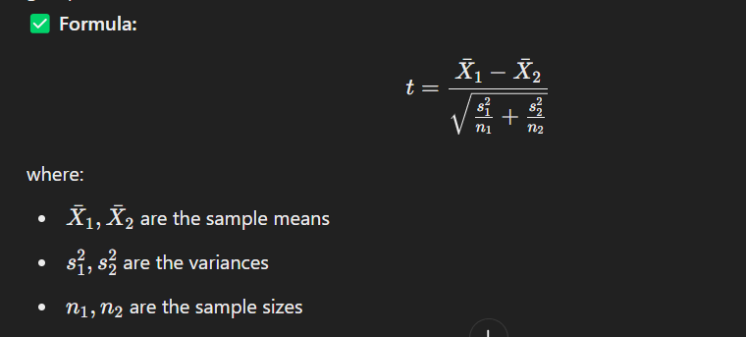
2. Paired Samples t-Test (Dependent t-Test)
✅ Use case: Compare means before and after an intervention (e.g., impact of a training program).
✅ Assumption: The two samples are related (e.g., same individuals before and after an event).
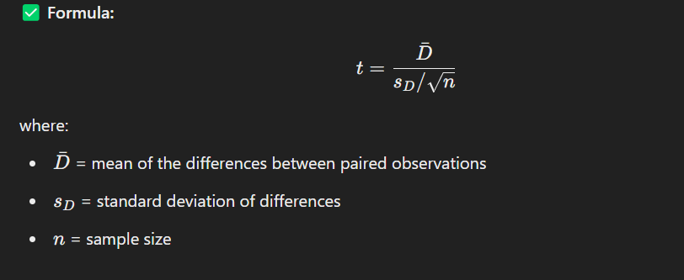
- Use an Independent t-Test for comparing two different groups (e.g., A/B testing).
- Use a Paired t-Test for comparing before-and-after situations (e.g., impact analysis).
- In real-world business, these tests help in decision-making, A/B testing, and assessing marketing impact.
(A). Independent t-Test (A/B Testing for Website Conversion)
Scenario: A company wants to test if a new website design (Version B) improves conversion rates compared to the old design (Version A).

Step 1: Define Hypotheses
- Null Hypothesis (H0​): There is no significant difference in conversion rates between Version A and Version B.
- Alternative Hypothesis (H1​): Version B has a significantly higher conversion rate.

Step 2: Given Data
Version | Sample Size (n) | Mean Conversion Rate (x bar) | Standard Deviation (s)
A (Old) | 500 | 3.2% (0.032) | 1.1% (0.011)
B (New) | 500 | 4.1% (0.041) | 1.3% (0.013)

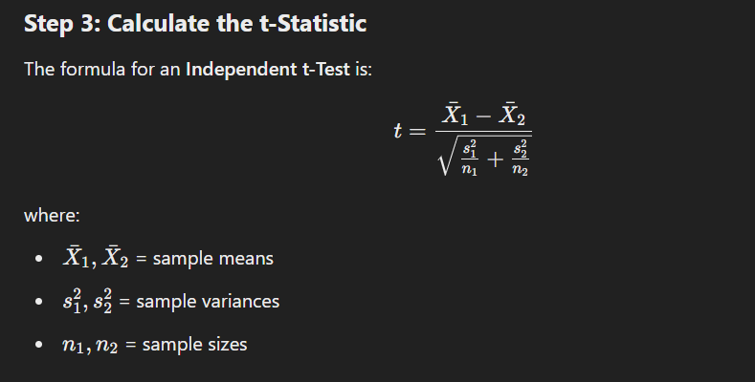
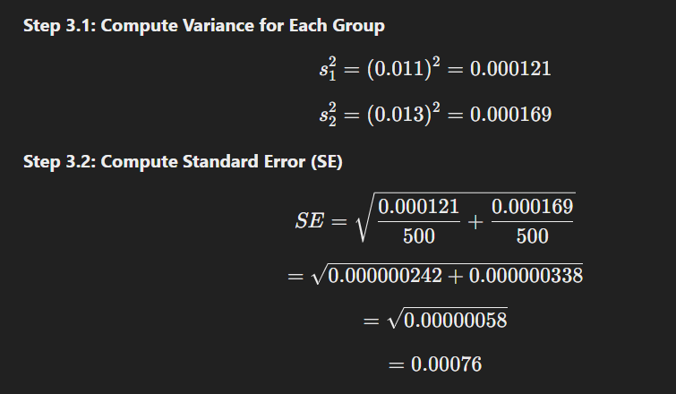
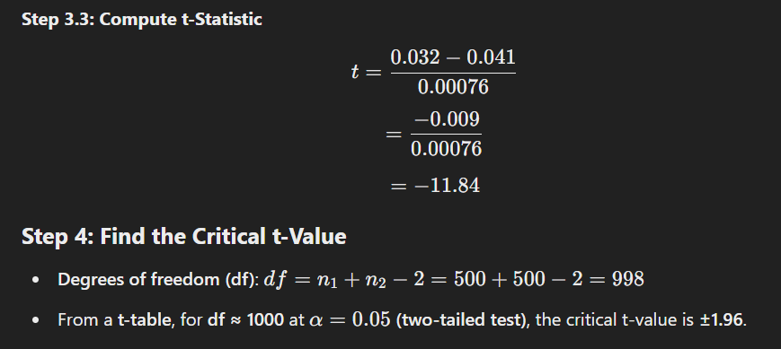
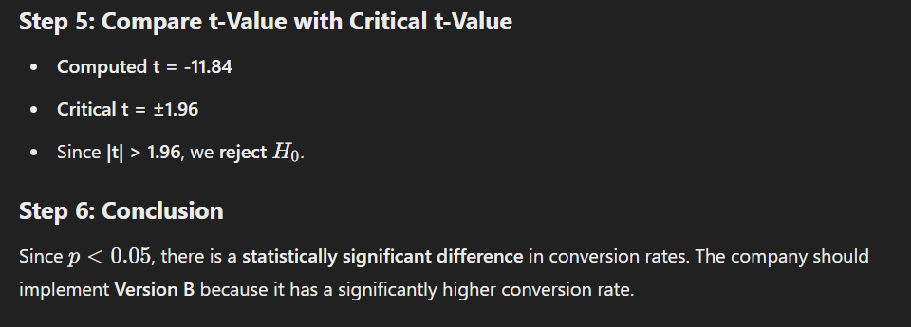

(B). Paired t-Test (Sales Before vs. After Marketing Campaign)
Scenario:
A company wants to see if a marketing campaign significantly increases customer sales.
Step 1: Define Hypotheses
- Null Hypothesis (H0): No significant difference in customer sales before and after the campaign.
- Alternative Hypothesis (H1​): The campaign increased customer sales.

Step 2: Given Data
Customer | Sales Before ($X_1$) | Sales After ($X_2$) | Difference ($D = X_2 - X_1$)
1 | 200 | 250 | 50
2 | 150 | 180 | 30
3 | 300 | 320 | 20
4 | 180 | 200 | 20
5 | 250 | 290 | 40

Step 3: Compute Mean and Standard Deviation of Differences

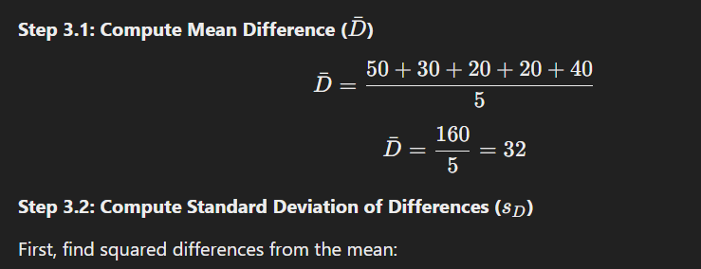

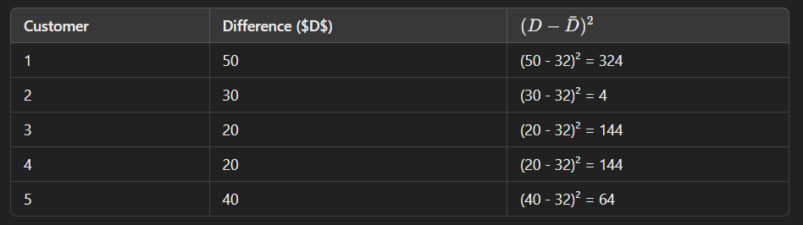

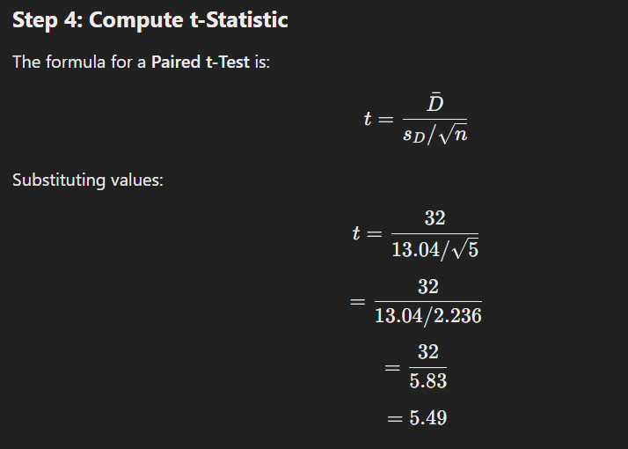
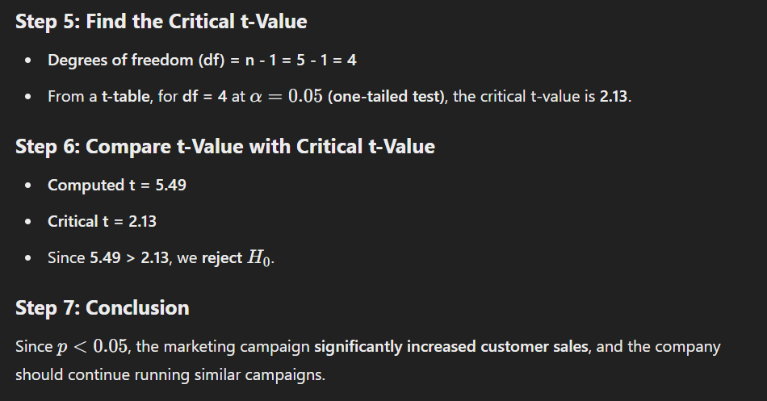

2. Z-Test: Detailed Explanation & Real-World Industrial Example
What is a Z-Test?
A Z-Test is a statistical test used to compare a sample mean to a population mean when the sample size is large (n≥30). It determines whether the observed difference is statistically significant or due to random chance.

When to Use a Z-Test?
✅ Population standard deviation (σ) is known
✅ Sample size is large (n≥30)
✅ Data is normally distributed (or follows the Central Limit Theorem)
If the sample size is small (n<30) and population standard deviation is unknown, use a t-Test instead.

Types of Z-Tests
- One-Sample Z-Test: Compares the sample mean to a known population mean.
- Two-Sample Z-Test: Compares the means of two independent samples.

(A). One-Sample Z-Test: Manual Calculation & Example
Industry Example: Average Salary of Data Analysts
A company claims that the average salary of a data analyst in New York is $85,000 per year. A researcher collects a random sample of 50 data analysts and finds the average salary is $82,000, with a known population standard deviation of $12,000.
We want to test if the average salary in the sample is significantly different from the claimed $85,000.

Step-by-Step Calculation of One-Sample Z-Test
Step 1: Define Hypotheses
- Null Hypothesis (H0): The population mean is $85,000 (μ=85,000)
- Alternative Hypothesis (H1​): The population mean is not $85,000 (μ≠85,000)
This is a two-tailed test since we are checking for any difference (higher or lower).

Step 2: Given Data
- Population Mean (μ) = 85,000
- Sample Mean (X bar) = 82,000
- Population Standard Deviation (σ) = 12,000
- Sample Size (n) = 50
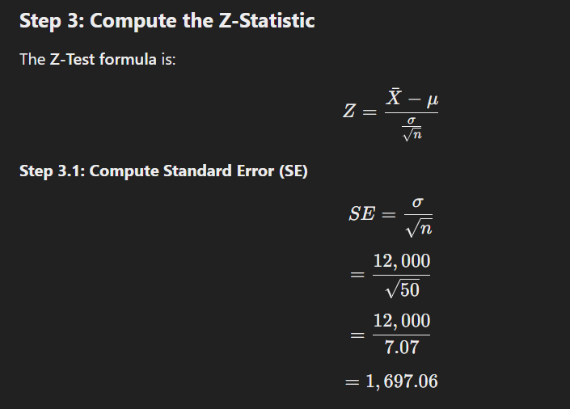
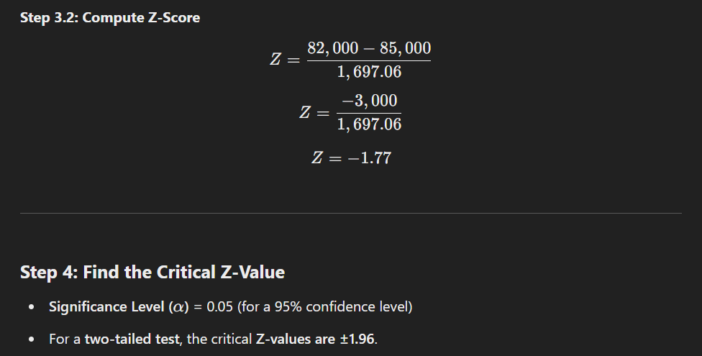
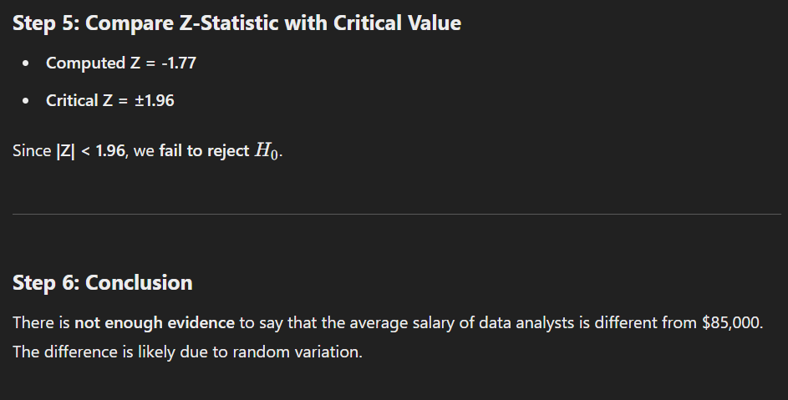

(B). Two-Sample Z-Test: Manual Calculation & Example
Industry Example: Customer Satisfaction in Two Cities
A retail company wants to compare customer satisfaction scores between New York and Los Angeles. They collect random samples from both cities.

Step-by-Step Calculation of Two-Sample Z-Test
Step 1: Define Hypotheses
- Null Hypothesis (H0​): There is no difference in customer satisfaction (μ1=μ2)
- Alternative Hypothesis (H1​): Customer satisfaction is different (μ1≠μ2​)
This is a two-tailed test.

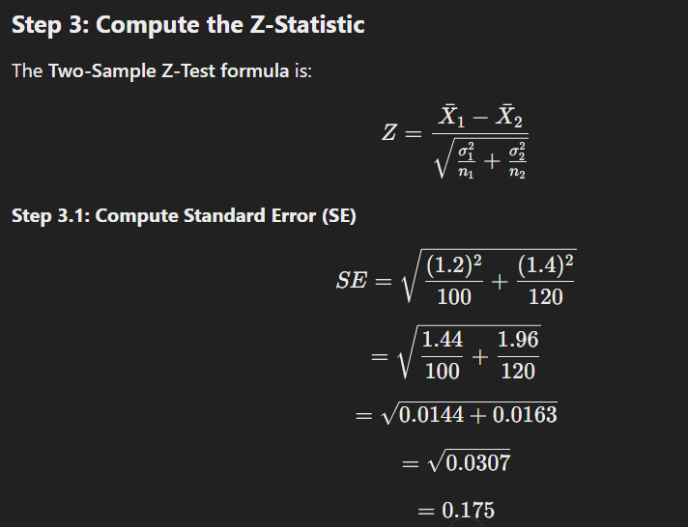
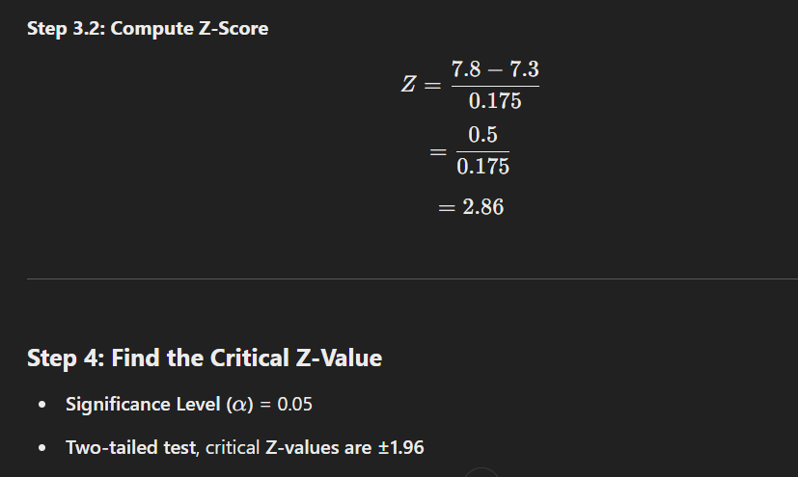
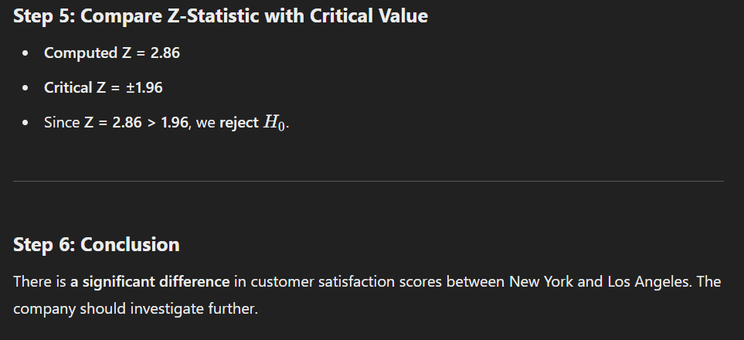
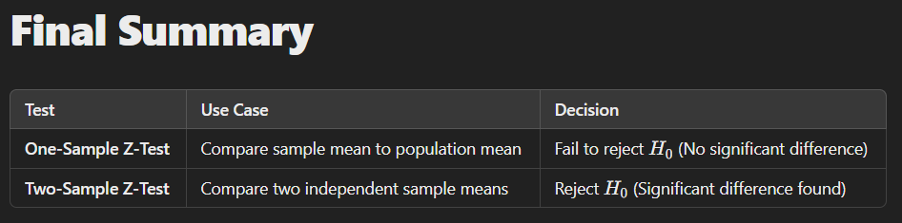

3. ANOVA (Analysis of Variance) – Detailed Explanation & Industrial Example
What is ANOVA?
ANOVA (Analysis of Variance) is a hypothesis testing technique used to compare the means of three or more groups to determine if they are significantly different.
It extends the t-Test, which compares only two groups, to multiple groups.

Types of ANOVA
- One-Way ANOVA – Compares the means of multiple groups based on one independent variable.
  - Example: Comparing customer satisfaction across three different store locations.
- Two-Way ANOVA – Compares means based on two independent variables.
  - Example: Analysing customer satisfaction across three store locations and two different shopping seasons (Summer vs. Winter).

(A). One-Way ANOVA: Industrial Example & Step-by-Step Manual Calculation
Industry Example: Customer Satisfaction Across Three Store Locations
A retail company wants to check whether customer satisfaction scores differ across three store locations (New York, Los Angeles, and Chicago).

Step 1: Define Hypotheses
- Null Hypothesis (H0​): All three store locations have the same average customer satisfaction score.
- Alternative Hypothesis (H1​): At least one store has a different customer satisfaction score.
This is a one-way ANOVA test because we are testing only one independent variable (Store Location).

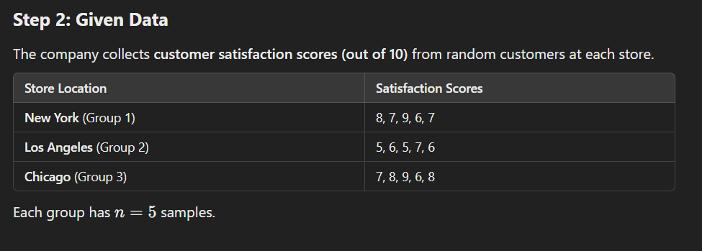
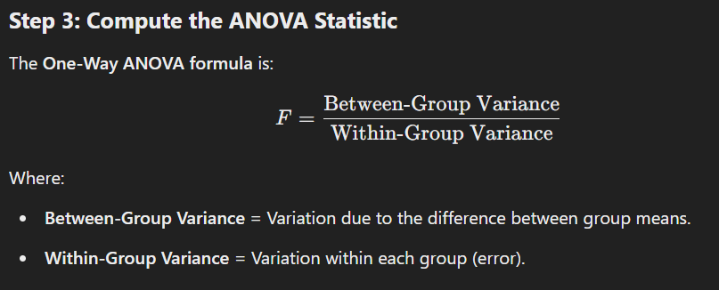
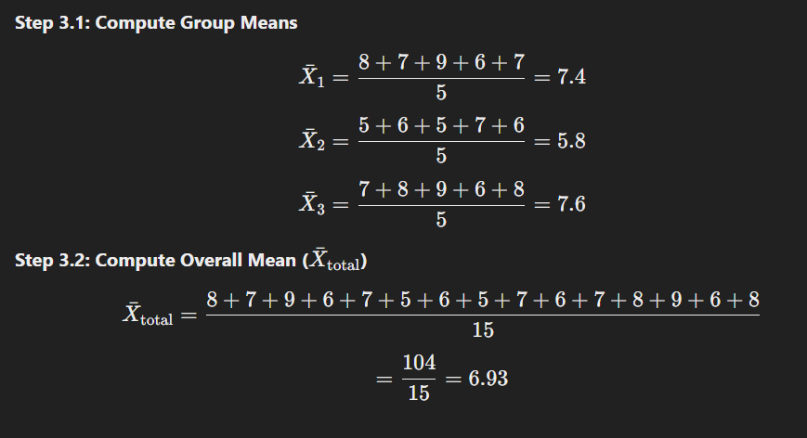
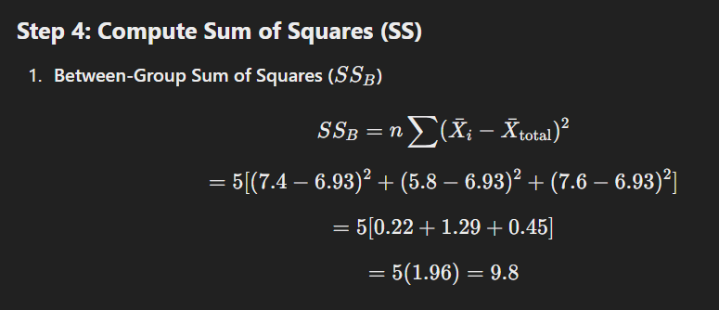
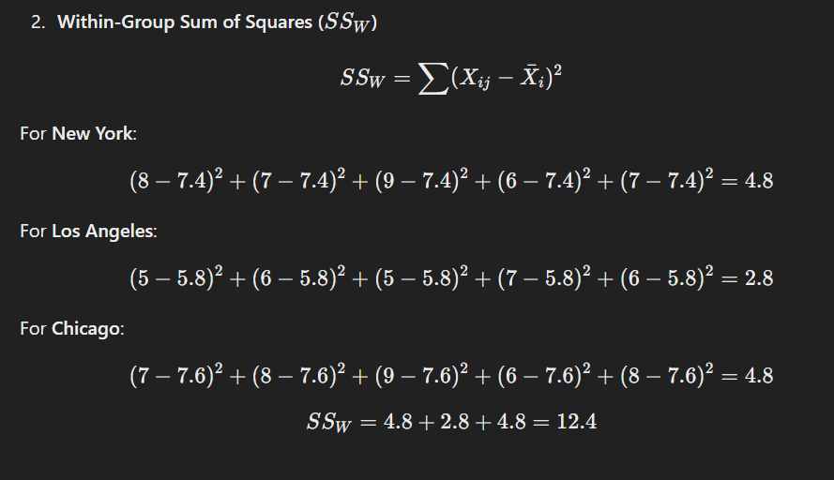

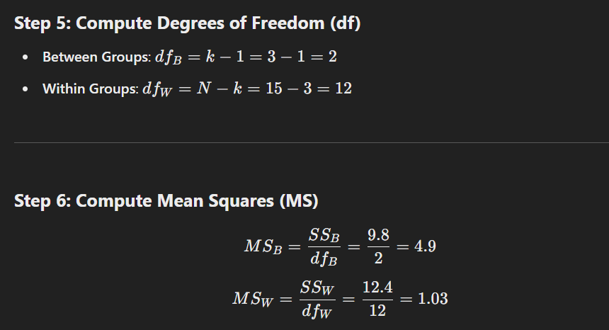
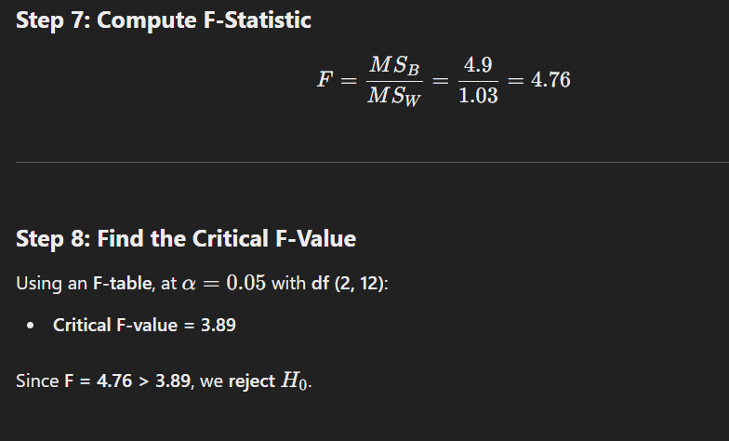

Step 9: Conclusion
At least one store has a significantly different customer satisfaction score. The company should investigate which store has the highest or lowest satisfaction.

(B). Two-Way ANOVA: Practical Example with Step-by-Step Calculation
Scenario: Customer Satisfaction Across Store Locations and Shopping Seasons
A retail company wants to analyse how customer satisfaction (out of 10) is affected by two factors:
- Store Location (New York, Los Angeles, Chicago)
- Shopping Season (Summer, Winter)
This is a Two-Way ANOVA because we have two independent variables (Store Location & Shopping Season).

Step 1: Define Hypotheses
- Null Hypotheses (H0):
  - No significant difference in satisfaction across store locations.
  - No significant difference in satisfaction between seasons.
  - No interaction effect between store location and season.
- Alternative Hypotheses (H1​):
  - At least one store has a different satisfaction score.
  - At least one season has a different satisfaction score.
  - There is an interaction effect (i.e., location and season together influence satisfaction).

Step 2: Given Data
The company surveys customers from each store during both Summer and Winter.
The table below shows customer satisfaction scores (out of 10):
Store Location | Summer Ratings | Winter Ratings
New York | 8, 9, 7, 6, 8 | 6, 7, 5, 6, 7
Los Angeles | 7, 6, 8, 7, 7 | 5, 6, 5, 6, 5
Chicago | 9, 8, 9, 7, 8 | 8, 7, 7, 6, 7
Each store has two groups (Summer & Winter), with 5 samples per group.
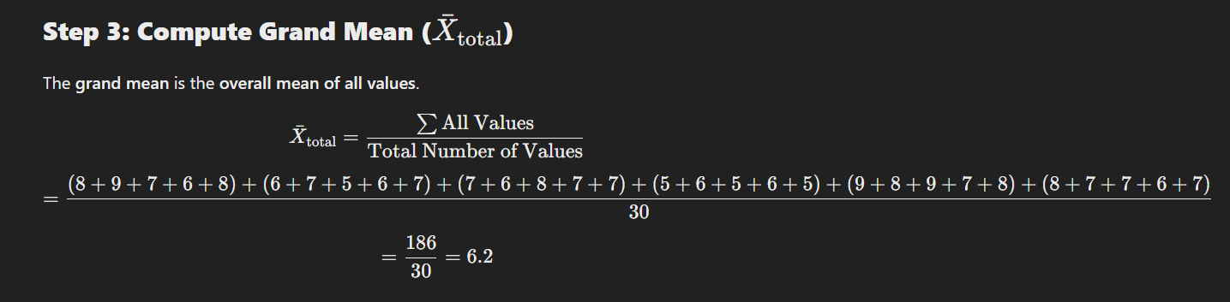
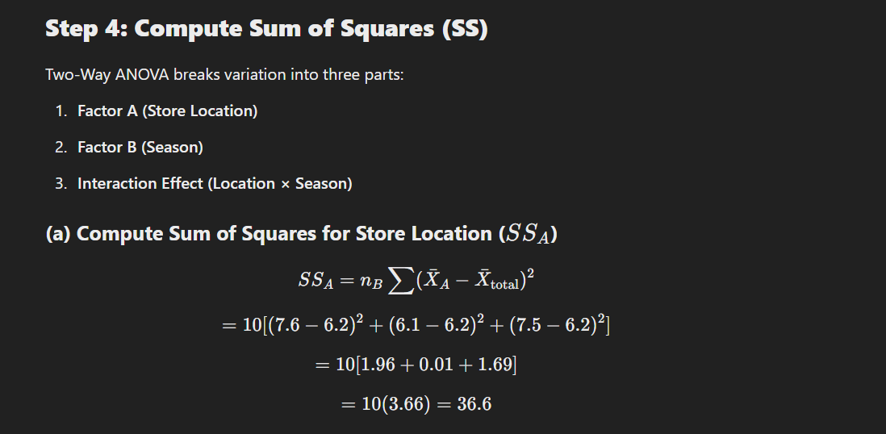

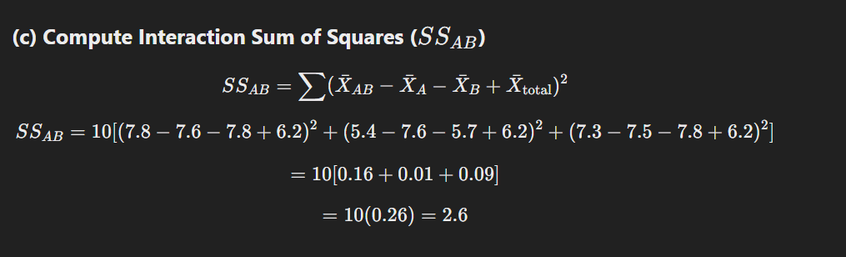
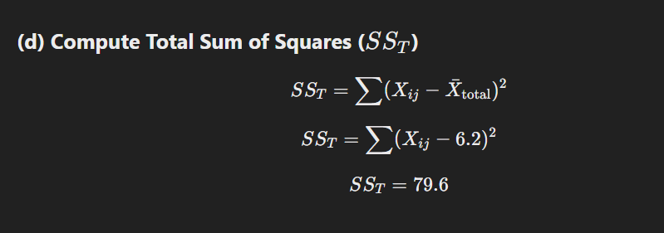
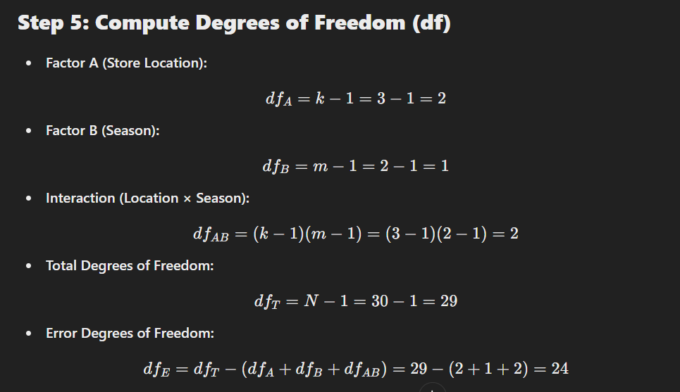
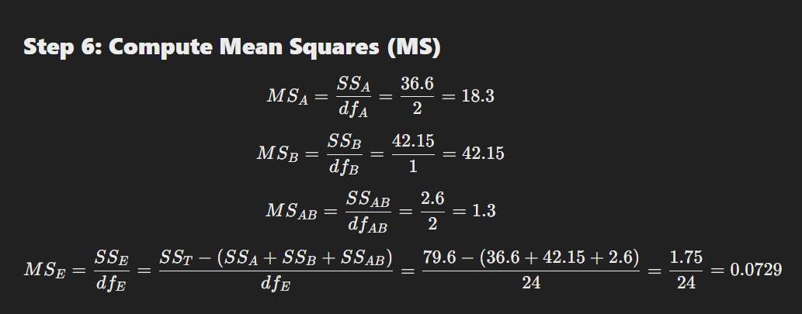

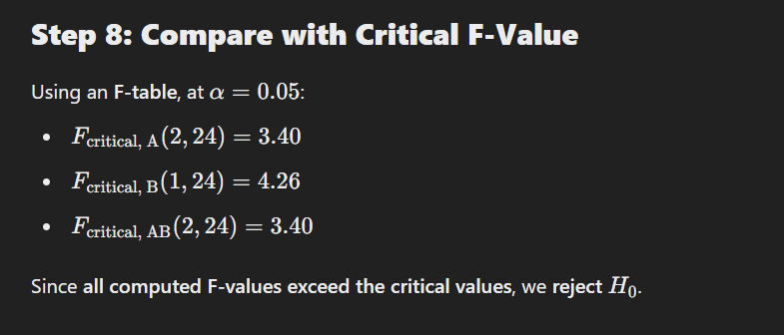


2. Relationship & Correlation Tests
- Pearson Correlation – Linear relationship between two continuous variables.
- Spearman’s Rank Correlation – Non-linear relationship between ordinal or skewed continuous data.
- Chi-Square Test – Association between categorical variables (customer preferences, survey analysis).

Pearson Correlation: Detailed Explanation & Industrial Example
What is Pearson Correlation?
Pearson correlation (r) measures the strength and direction of the linear relationship between two continuous variables.
It ranges from -1 to +1:
- r=+1: Perfect positive correlation (as one variable increases, the other increases).
- r=−1: Perfect negative correlation (as one variable increases, the other decreases).
- r=0: No correlation (no linear relationship).
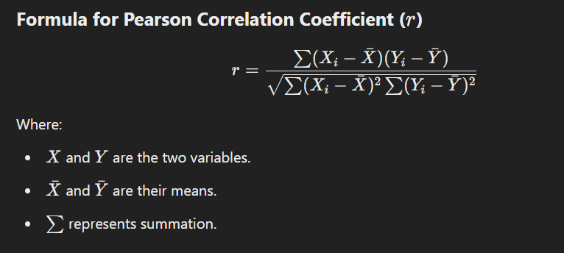

Industrial Example: Pearson Correlation in Retail Sales & Advertising Spend
A retail company wants to understand if there is a linear relationship between advertising spend and sales revenue.
Step 1: Collect Real-Time Data
The company collects data over 10 months:
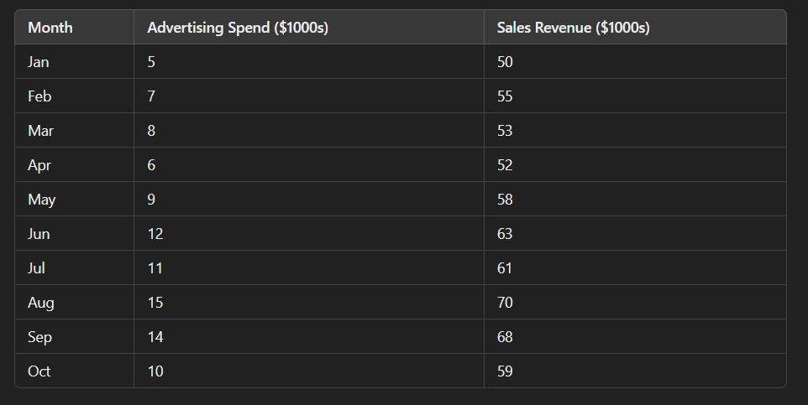
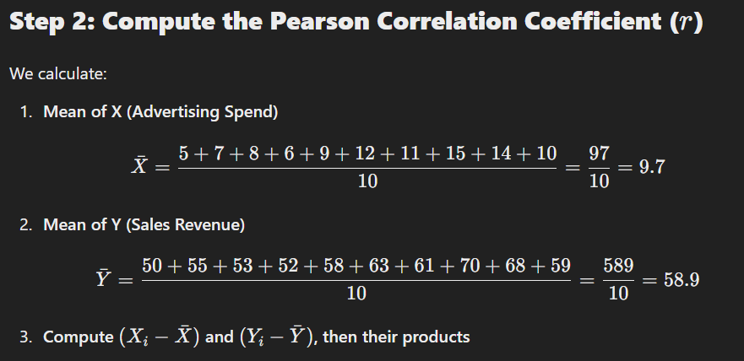
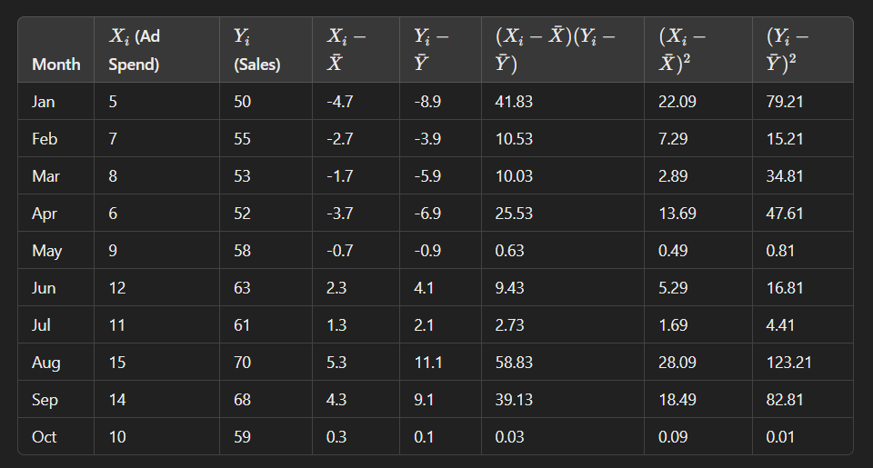
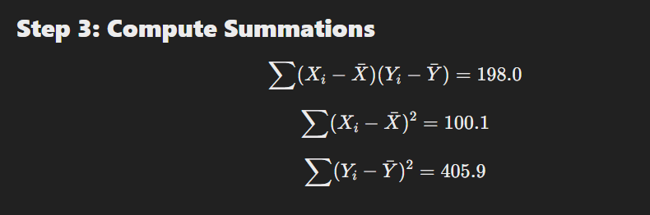

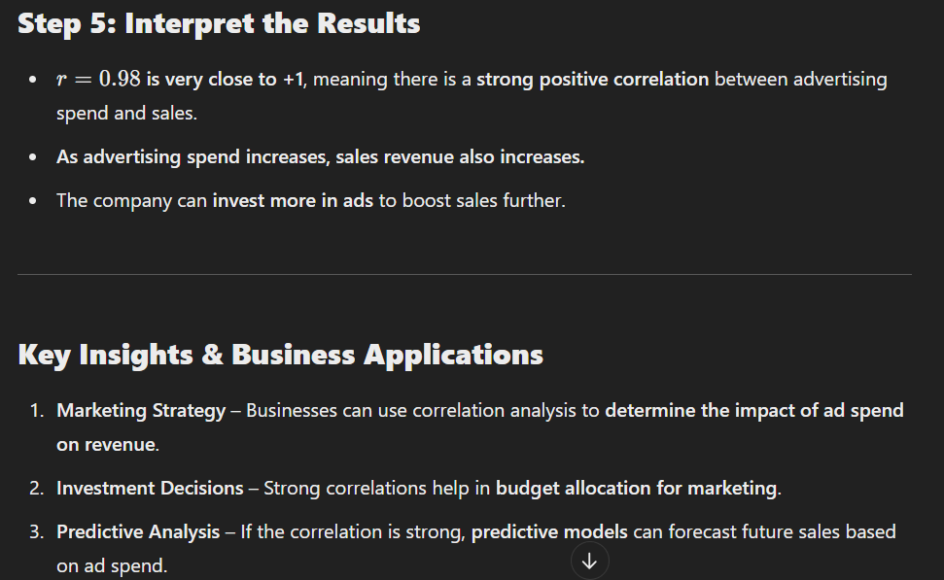

Spearman’s Rank Correlation: Explanation & Industrial Example
What is Spearman’s Rank Correlation?
Spearman’s Rank Correlation (rs​) measures the strength and direction of the monotonic relationship between two ordinal or non-normally distributed continuous variables.
Unlike Pearson correlation, which measures linear relationships, Spearman correlation captures monotonic relationships, meaning:

- If one variable increases, the other tends to increase or decrease consistently (but not necessarily at a constant rate).
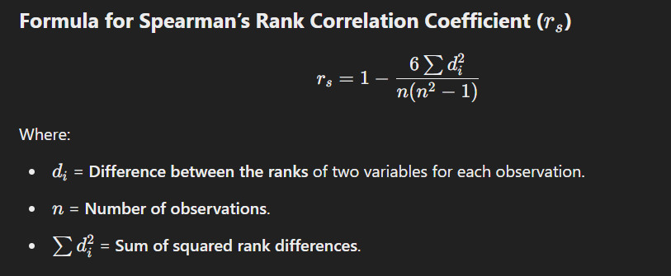
Industrial Example: Employee Experience & Job Performance
Business Case:
A company wants to analyse whether employee experience (years of service) is correlated with job performance ratings.
Step 1: Collect Real-Time Data
The HR department collects data from 10 employees.
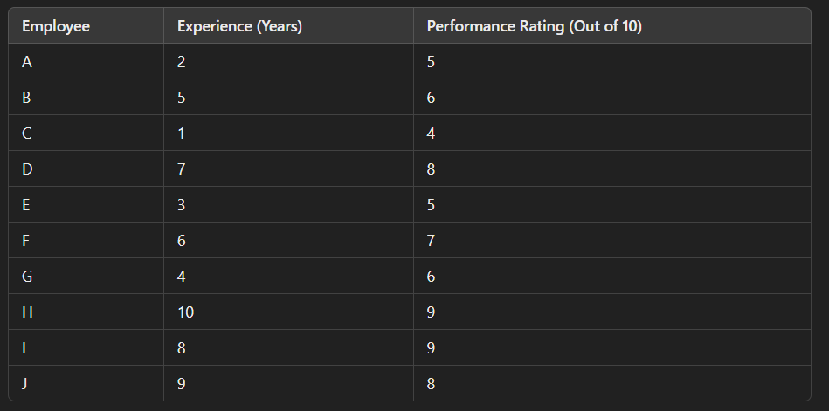
Since experience is continuous, but not normally distributed (skewed), and performance rating is ordinal, Spearman correlation is ideal.

Step 2: Rank the Data
We replace raw values with their ranks.
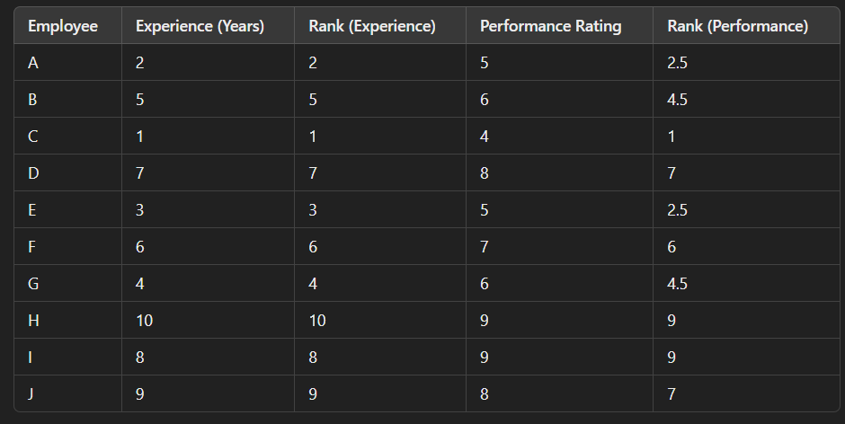
If values tie, assign them the average rank (e.g., both ratings of 5 get rank 2.5).
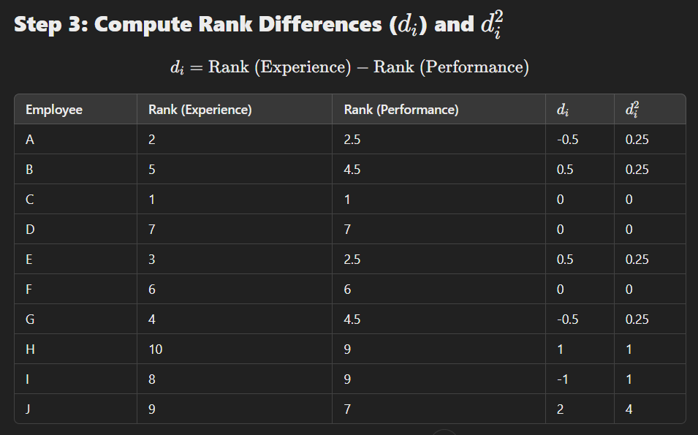
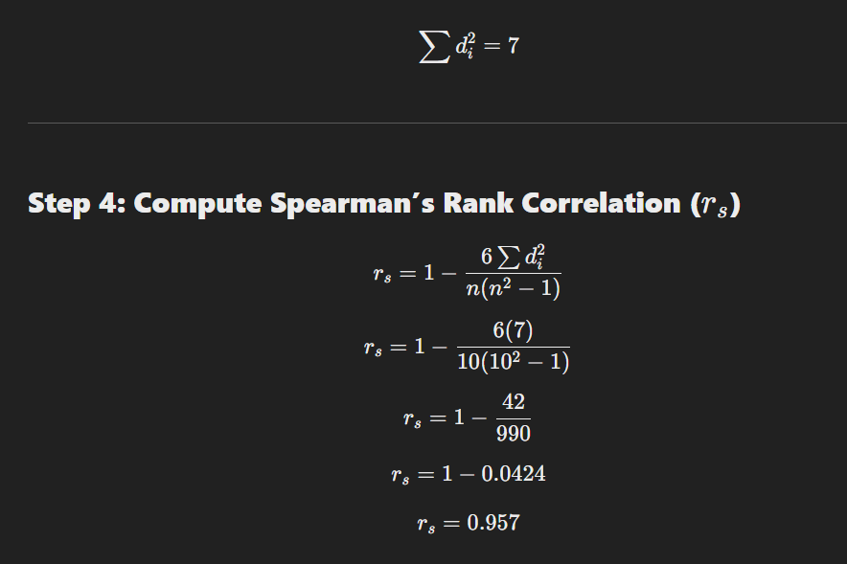
Key Business Insights
- HR Policy – Spearman’s rank can help HR understand what truly drives employee satisfaction.
- Non-Linear Relationships – Unlike Pearson, it detects non-linear effects (e.g., salary beyond a certain point has diminishing returns).
- Market Research – Used in customer preference analysis, where brand perception vs. actual sales might not be linear.

Chi-Square Test: Explanation & Industrial Example
What is the Chi-Square Test?
The Chi-Square test (χ2) is a statistical test used to determine the association between two categorical variables in a dataset. It compares observed frequencies with expected frequencies under the assumption of independence.
When to Use the Chi-Square Test?
- When both variables are categorical (e.g., Gender vs. Product Preference).
- To check if there is a statistically significant relationship between them.
- Common in market research, healthcare, and business analytics.

Types of Chi-Square Tests
- Chi-Square Goodness of Fit – Tests whether a sample follows a known distribution.
- Chi-Square Test of Independence – Tests whether two categorical variables are related.
We will focus on Chi-Square Test of Independence.
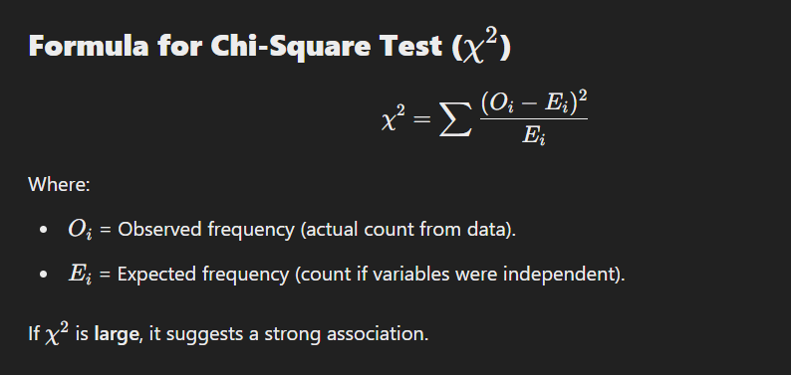
Industrial Example: Chi-Square Test in Customer Preferences
A supermarket wants to analyse if there is a relationship between Age Group and Preferred Product Category.
Step 1: Collect Data (Observed Frequency)
The store surveys 300 customers about their preferred product category:
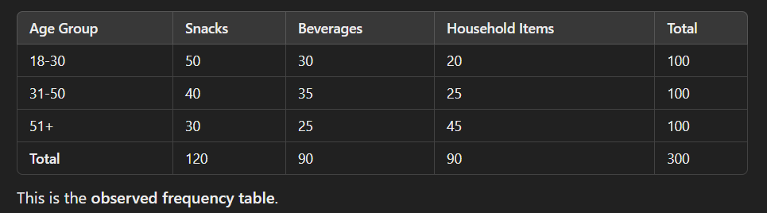
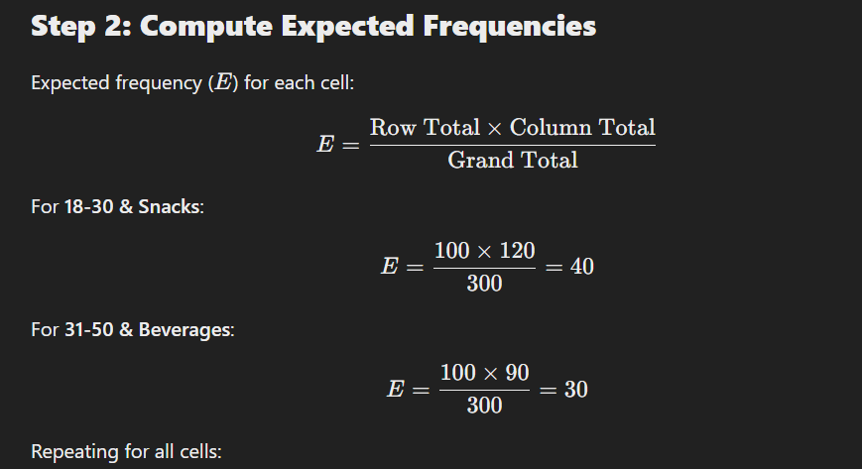

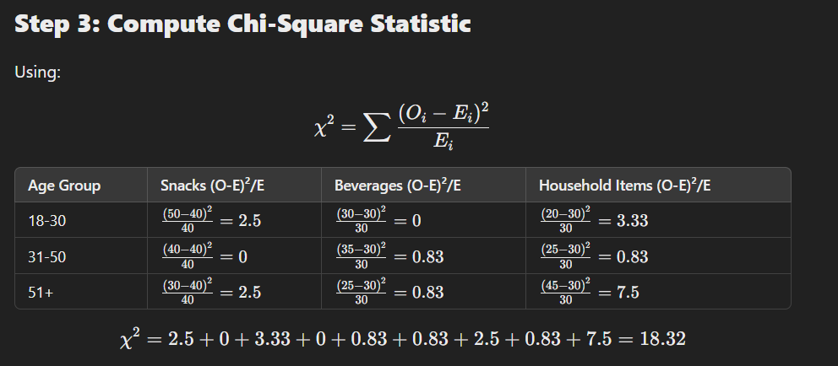
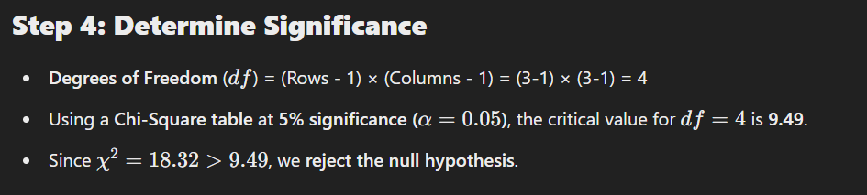

Step 5: Conclusion & Business Insights
- There is a significant relationship between Age Group and Product Preference.
- The supermarket can now target age-specific promotions:
  - Younger customers (18-30) prefer snacks, so they should offer discounts on chips and chocolates.
  - Older customers (51+) prefer household items, so they should increase inventory for cleaning supplies.
- This helps in better inventory management and targeted marketing.

Regression Analysis (Predictive Analytics)
What is Regression Analysis?
Regression analysis is a predictive modelling technique that estimates the relationship between independent variables (predictors) and a dependent variable (outcome).
It is widely used for:
✅ Sales Forecasting
✅ Trend Analysis
✅ Risk Assessment
✅ Customer Demand Prediction
Types of Linear Regression
- Simple Linear Regression – One independent variable.
Y= β0 + β1X + ϵ
Example: Predicting sales based on advertising spend.

- Multiple Linear Regression – Two or more independent variables.
Y= β0 + β1X1 + β2X2 +...+ βnXn + ϵ
Example: Predicting house prices based on size, location, and number of bedrooms.

1. Dependent Variable (Y)
- Y is the outcome or target variable we are trying to predict.
- It is a continuous variable (e.g., sales revenue, customer spending, temperature, etc.).
- Example: Predicting monthly sales ($1000s) based on advertising spend → Y=Sales.
2. Intercept (β0)
- β0 is the baseline value of Y when X=0.
- It represents the value of the dependent variable when there is no influence from the independent variable.
- Example: If β0=5, then when ad spend is zero, the sales will still be $5000 due to other factors.

3. Slope Coefficient (β1​)
- β1 represents the rate of change of Y for every 1-unit increase in X.
- It shows how strongly the independent variable affects the dependent variable.
- Example: If β1= 0.8, it means every $1000 increase in ad spend increases sales by $800.
4. Independent Variable (X)
- X is the predictor variable or independent variable.
- It is the input variable we use to predict Y.
- Example: Advertising Spend is an independent variable used to predict Sales.
5. Error Term (ϵ)
- ϵ\epsilonϵ represents the random error in the model.
- It accounts for all unexplained factors that affect Y but are not included in the model.
- Example: Sales may be affected by economic conditions, competitor promotions, weather, etc., which are not captured by ad spend alone.

Final Interpretation
Sales = 5 + 0.8 × (Ad Spend) + ϵ
- When Ad Spend = 0, the baseline sales are $5000.
- For every $1000 increase in Ad Spend, sales increase by $800.
- The actual sales will fluctuate due to external factors (ϵ\epsilonϵ).

Industrial Example: Sales Forecasting with Multiple Regression
A company wants to predict monthly sales ($1000s) based on advertising spend (TV, Radio, social media).
Step 1: Collect Data
We collect 10 months of data on sales and ad spending.

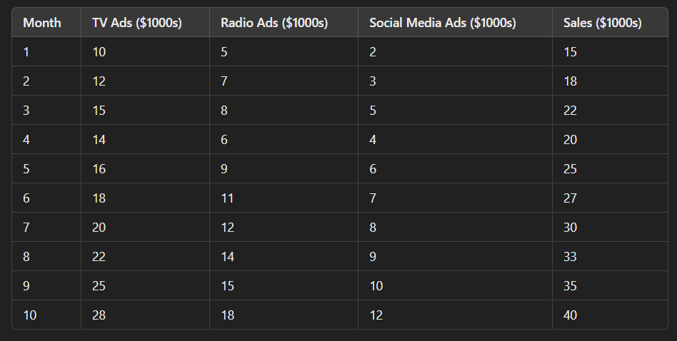

Step 2: Define the Regression Model
Sales = β0 + β1(TV Ads) + β2(Radio Ads) + β3(Social Media Ads) + ϵ
Where:
- Sales = Target variable (Dependent variable).
- TV Ads, Radio Ads, Social Media Ads = Independent variables (Predictors).
- β0​ (Intercept) = Base sales when no ads are run.
- β1, β2, β3​ = Regression coefficients showing impact per $1000 spent.

Step 3: Compute Regression Coefficients
We calculate the regression coefficients using Least Squares Method or software like Python, Excel, or R.
Let's assume we obtain:
Sales = 5 + 0.8(TV Ads) + 0.5(Radio Ads) + 0.7(Social Media Ads)

Step 4: Make Predictions
Now, if the company plans to spend $20,000 on TV, $10,000 on Radio, and $6,000 on social media, the predicted sales:
Sales = 5 + (0.8×20) + (0.5×10) + (0.7×6)
🔹 Predicted Monthly Sales = $30,200
Step 5: Interpret the Results
- TV Ads have the biggest impact (β1=0.8), meaning every $1000 increase in TV ads increases sales by $800.
- Social Media Ads (β3=0.7) are also effective, so investing more in digital ads is recommended.
- Radio Ads have a lower impact (β2=0.5), meaning they contribute less to sales.

Business Insights & Applications
✔ Budget Allocation – Shift marketing budget towards the most effective channel (TV & social media).
✔ Forecasting Revenue – Helps companies predict future revenue based on planned ad spend.
✔ Product Launch Strategy – Companies can estimate potential sales before launching a new product.

Logistic Regression: Predictive Analytics for Categorical Outcomes
What is Logistic Regression?
Logistic Regression is a statistical method used for predicting categorical outcomes, especially binary classification problems (Yes/No, 0/1, Success/Failure). Unlike Linear Regression, which predicts continuous values, Logistic Regression predicts probabilities.
It is widely used in:
✅ Customer Churn Prediction (Will a customer leave or stay?)
✅ Fraud Detection (Is a transaction fraudulent or not?)
✅ Disease Diagnosis (Does a patient have a disease or not?)

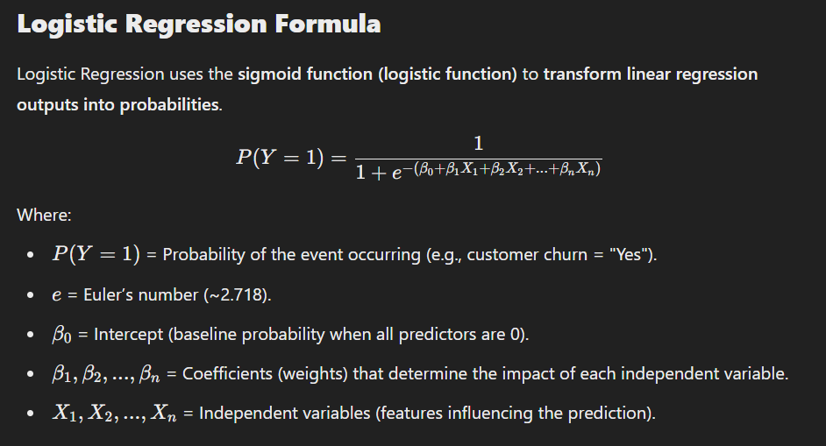
Industrial Example: Customer Churn Prediction
A telecom company wants to predict whether a customer will churn (leave the service) or not based on customer data.

Step 1: Collect Data
The company collects historical customer data, including Monthly Charges, Contract Type, and Customer Tenure.
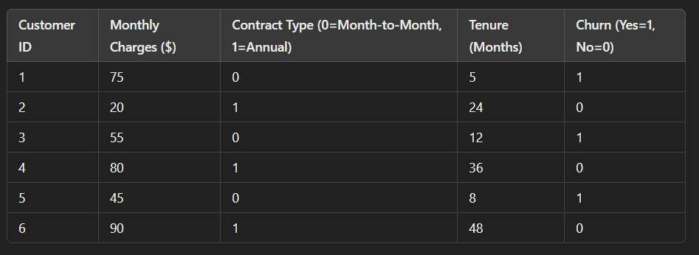
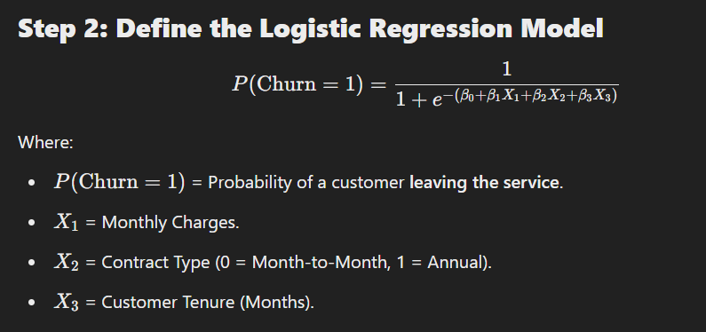
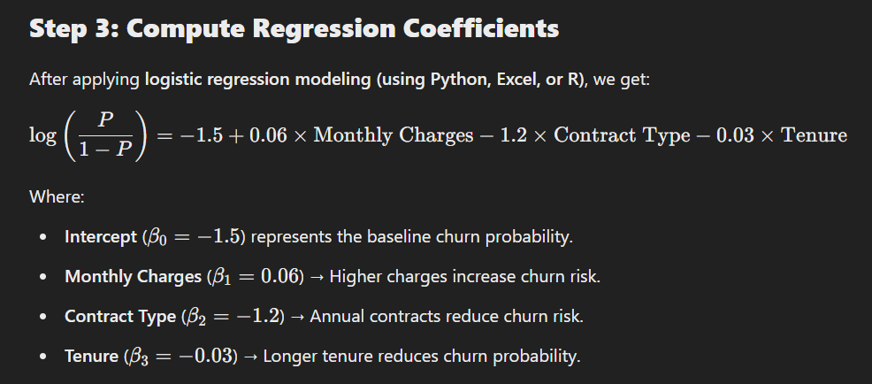
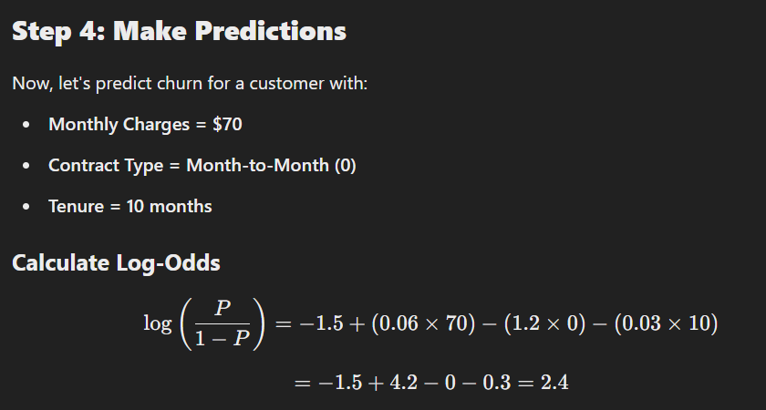
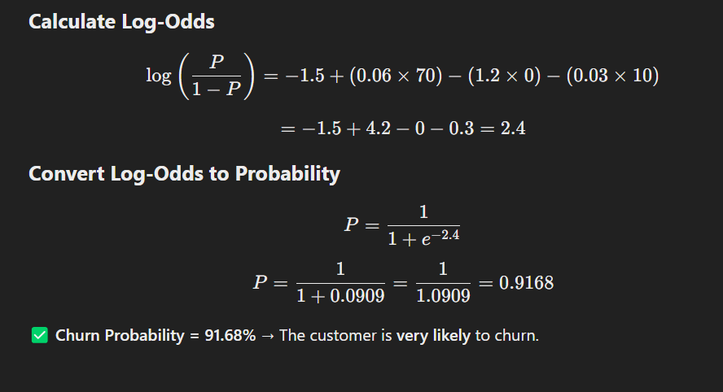
Step 5: Business Insights
📌 High Monthly Charges → Encourage customers to switch to annual plans by offering discounts.
📌 Month-to-Month Customers → Target them with loyalty programs to prevent churn.
📌 Short Tenure Customers → Engage them with onboarding support & discounts to improve retention.

Mann-Whitney U Test: A Non-Parametric Alternative to t-Test
What is the Mann-Whitney U Test?
The Mann-Whitney U test (also called the Wilcoxon Rank-Sum test) is a non-parametric test used to compare two independent groups when:
✔ Data is not normally distributed (violates the normality assumption).
✔ Data is ordinal, skewed, or contains outliers.
✔ Sample sizes are small.
🔹 Unlike the t-test, which compares means, the Mann-Whitney U test compares medians and determines whether one group tends to have higher or lower values than the other.
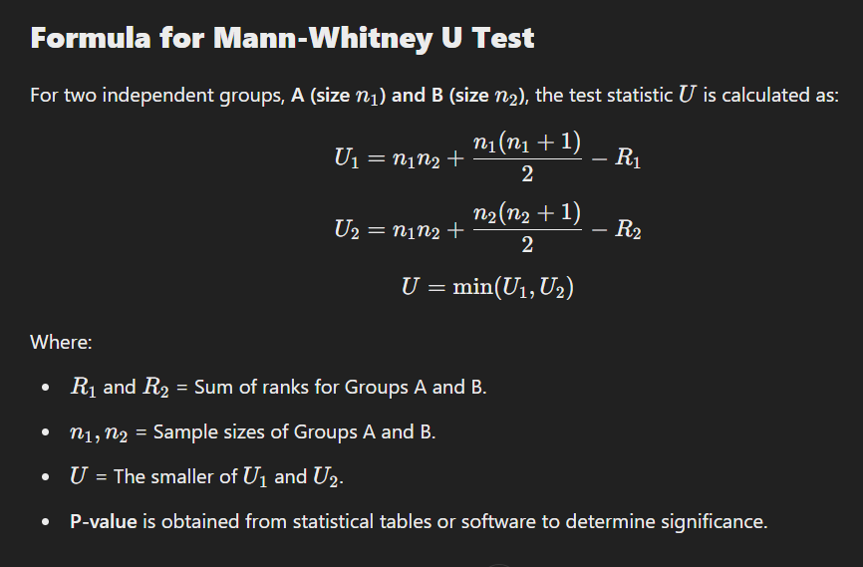
Industrial Example: Employee Productivity Analysis
Scenario
A company wants to determine if remote employees have significantly different productivity compared to office employees.
✔ Group A: Employees working from office.
✔ Group B: Employees working remotely.
✔ Productivity Score: Measured on a 100-point scale.
✔ Data is not normally distributed (skewed), so we use Mann-Whitney U test instead of a t-test.
Step 1: Collect Data
We collect productivity scores from 10 employees in each group.
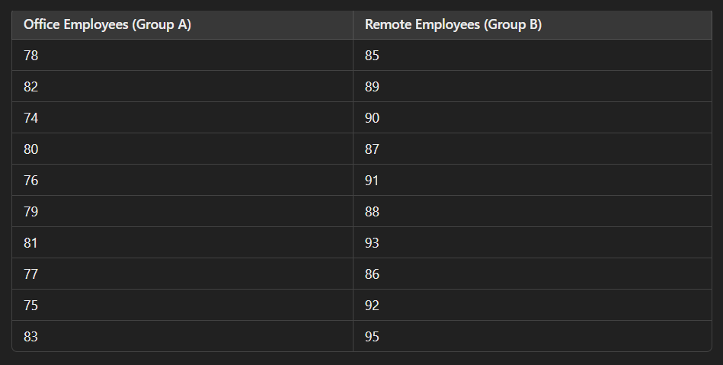
Step 2: Rank the Data
We rank all 20 scores from lowest to highest.

- Sum of Ranks (Office employees):
R1=1+2+3+4+5+6+7+8+9+10=55
- Sum of Ranks (Remote employees):
R2=11+12+13+14+15+16+17+18+19+20=155

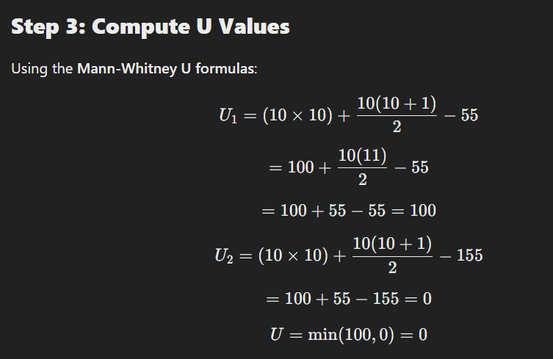
Step 4: Determine Statistical Significance
We compare the calculated U-value with the critical U-value from statistical tables at α=0.05 (95% confidence level).
For n1=10, n2=10 the critical U-value from the table is 23.
Since U = 0 < 23, we reject the null hypothesis.

Step 5: Conclusion & Business Insights
📌 Remote employees have significantly higher productivity than office employees.
📌 The company should consider hybrid work models to improve productivity.
📌 If there are other factors (distractions, work environment), further research should be conducted.

Key Takeaways
✅ Mann-Whitney U Test is useful for comparing non-normal or skewed data.
✅ It is an alternative to the t-test when assumptions of normality and equal variance are violated.
✅ Widely used in HR analytics, medicine, customer behaviour studies, and operational performance analysis.

Kruskal-Wallis Test: A Non-Parametric Alternative to ANOVA
What is the Kruskal-Wallis Test?
The Kruskal-Wallis test is a non-parametric alternative to One-Way ANOVA used to compare three or more independent groups when:
✔ The data is not normally distributed (violates normality assumption).
✔ The groups have different sample sizes.
✔ The data is ordinal or skewed.
🔹 Unlike ANOVA, which compares means, the Kruskal-Wallis test compares medians and rank distributions to determine if at least one group differs significantly.

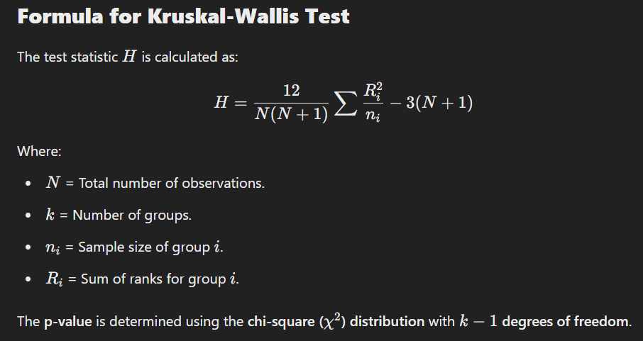
Industrial Example: Customer Satisfaction Analysis
Scenario
A company wants to analyse if customer satisfaction levels differ across three different service centres.
✔ Groups:
- Service Centre A
- Service Centre B
- Service Centre C
✔ Customer Satisfaction Scores (on a scale of 1-10).
✔ Data is not normally distributed (skewed), so we use the Kruskal-Wallis test instead of ANOVA.
Step 1: Collect Data
Customer satisfaction scores from 15 customers at each center:
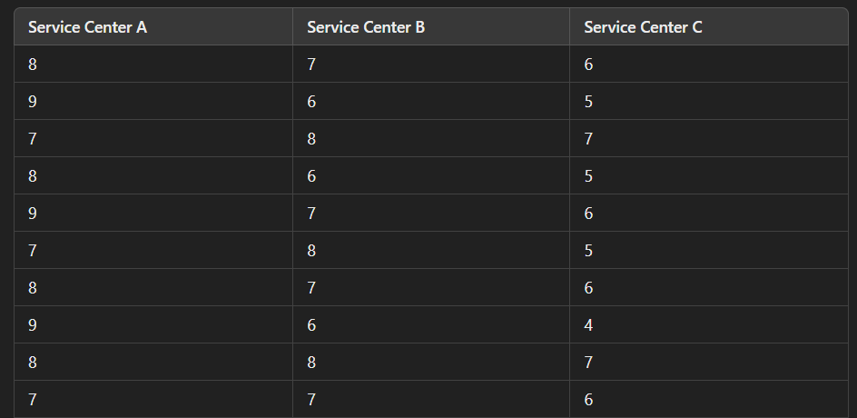

Step 2: Rank the Data
We rank all 45 scores from lowest to highest.



- Sum of Ranks (A):
RA=25.5+25.5+25.5+25.5+34+34+34+34+17+17=276
- Sum of Ranks (B):
RB=17+17+17+17+17+17+17+17+25.5+25.5+25.5+25.5+34+34=268.5
- Sum of Ranks (C):
RC=1.5+1.5+3.5+3.5+3.5+3.5+3.5+10+10+10+10+10+10+10+17=117.5

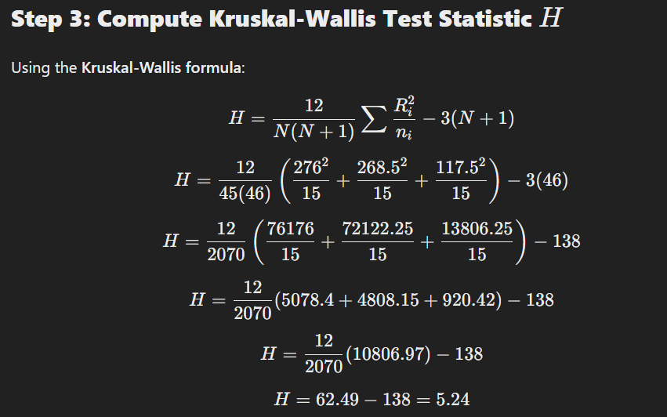
Step 4: Determine Statistical Significance
We compare the calculated H=5.24 with the critical chi-square value at α=0.05 for df = k−1 = 3−1 = 2
📌 Critical χ2 value from table = 5.99.
Since H = 5.24 < 5.99, we fail to reject the null hypothesis.

Step 5: Conclusion & Business Insights
📌 No significant difference in customer satisfaction among the three service centres.
📌 The company does not need to prioritize changes in a specific centre.
📌 Further investigation may be needed into individual service factors.

Key Takeaways
✅ Kruskal-Wallis Test is a powerful alternative when ANOVA assumptions are violated.
✅ It is widely used in customer satisfaction analysis, HR evaluations, healthcare studies, and market research.
✅ Works best when data is ordinal, skewed, or has outliers.

Wilcoxon Signed-Rank Test: A Non-Parametric Alternative to Paired t-Test
What is the Wilcoxon Signed-Rank Test?
The Wilcoxon Signed-Rank Test is a non-parametric alternative to the paired t-test used when:
✔ The data is not normally distributed (violates normality assumption).
✔ The same group is measured before and after a treatment (paired samples).
✔ The goal is to check whether the median difference between paired observations is significantly different from zero.
🔹 Unlike the paired t-test, which compares means, the Wilcoxon Signed-Rank Test compares ranks of differences.

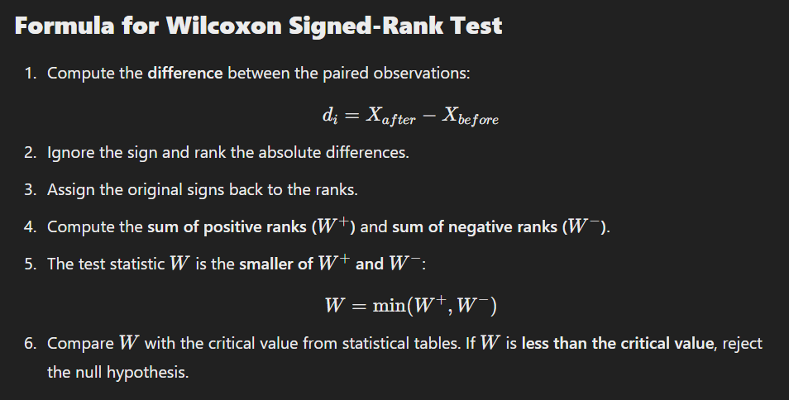
Industrial Example: Productivity Improvement After Training
Scenario
A company wants to test if a new employee training program improves employee productivity.
✔ 10 employees are selected for training.
✔ Productivity (hours worked effectively per day) is recorded before and after training.
✔ Data is not normally distributed (so we use Wilcoxon instead of paired t-test).
Step 1: Collect Data
Employee productivity before and after training:
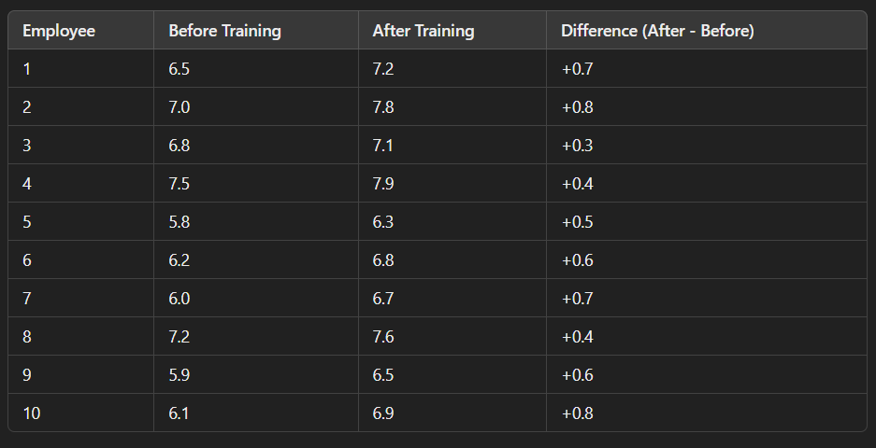
Step 2: Rank Absolute Differences
We rank the absolute differences from smallest to largest.
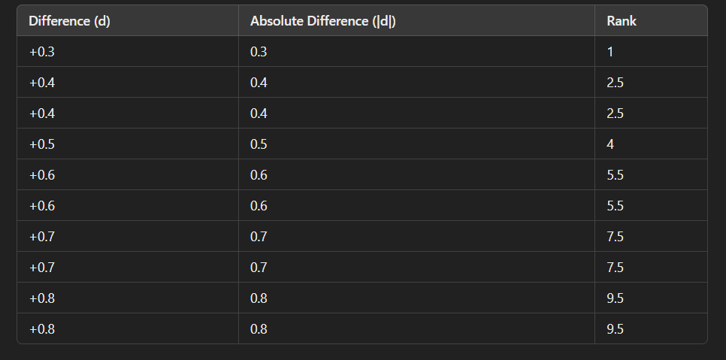
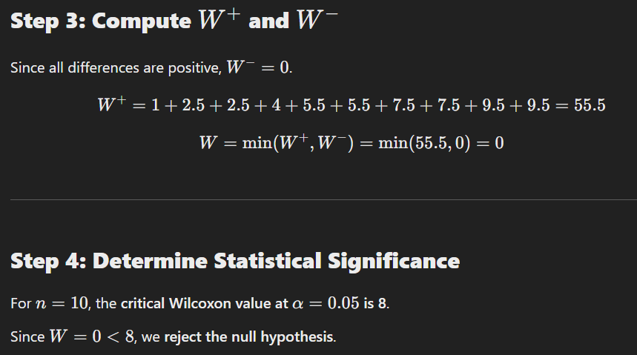
Step 5: Conclusion & Business Insights
📌 The training program significantly improves employee productivity.
📌 The company should continue the training program for all employees.
📌 Further research can explore which aspects of the training contributed most to the improvement.

Key Takeaways
✅ Wilcoxon Signed-Rank Test is useful for paired samples when data is non-normal.
✅ It is widely used in HR analytics, healthcare research, product testing, and finance.
✅ Works best for small sample sizes with skewed data or outliers.

Chi-Square Goodness of Fit Test: Testing If Observed Frequencies Match Expected Frequencies
What is the Chi-Square Goodness of Fit Test?
The Chi-Square Goodness of Fit test is a non-parametric test used to determine if an observed distribution fits an expected distribution.
When to Use This Test?
✔ The data consists of categorical variables.
✔ You want to check if an observed frequency distribution differs from an expected distribution.
✔ The sample size is large enough (expected frequency in each category should be ≥ 5).
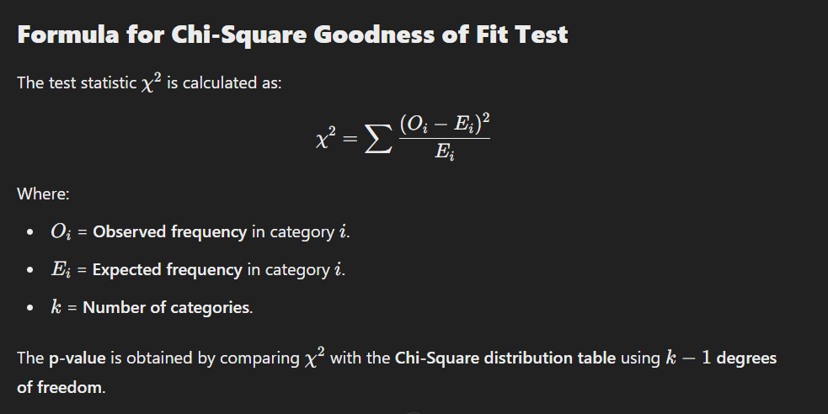
Industrial Example: Customer Purchase Behavior in a Retail Store
Scenario
A retail store sells products in four categories:
- Electronics
- Clothing
- Home Appliances
- Groceries
The store expects sales to be proportional to the following breakdown, based on past data:
- Electronics: 30%
- Clothing: 25%
- Home Appliances: 20%
- Groceries: 25%
However, after a marketing campaign, the store collects actual sales data from 400 customers and wants to check if the new purchase pattern follows the expected distribution.
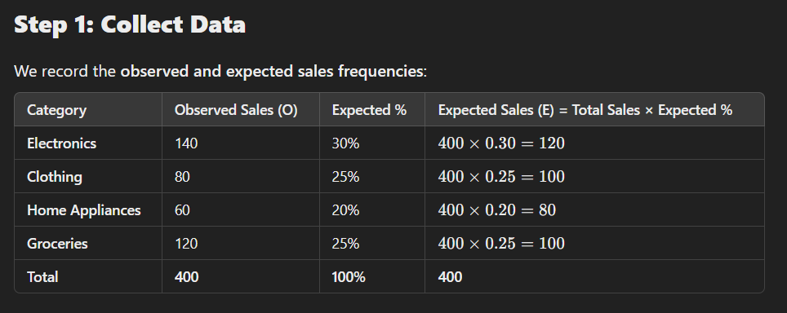
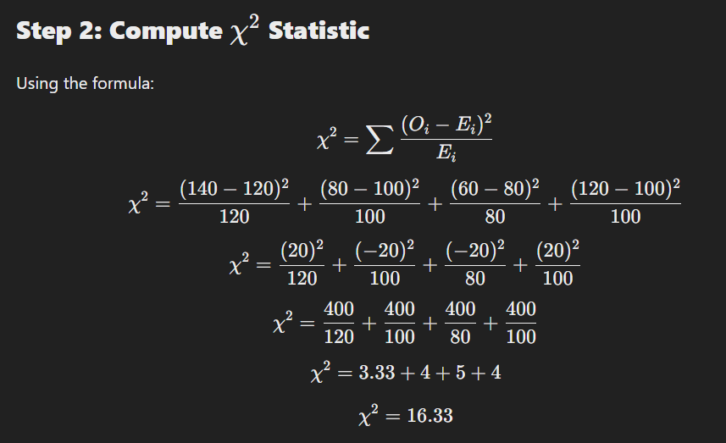
Step 3: Determine Statistical Significance
We compare the calculated χ2=16.33 with the critical Chi-Square value from a statistical table.
Degrees of Freedom
df = k – 1 = 4−1 = 3
From the Chi-Square table, the critical value at α=0.05 or df = 3 is 7.815.
Compare
Since 16.33 > 7.815, we reject the null hypothesis.

Step 4: Conclusion & Business Insights
📌 The new purchase pattern is significantly different from the expected sales distribution.
📌 The marketing campaign changed customer purchasing behaviour.
📌 The store should analyse why Electronics sales increased and why Clothing & Home Appliances underperformed.

Key Takeaways
✅ Chi-Square Goodness of Fit Test is used to check if observed frequencies match expected frequencies.
✅ It is widely used in retail, finance, healthcare, marketing, and manufacturing.
✅ Works best for categorical data with large sample sizes.

5. Proportion & Frequency Tests
- Chi-Square Goodness of Fit – Testing if observed frequencies match expected frequencies.
- Z-Test for Proportions – Comparing proportions of two groups (conversion rate analysis)

Z-Test for Proportions: Comparing Proportions of Two Groups
What is the Z-Test for Proportions?
A Z-Test for Proportions is a statistical test used to compare the proportions of two independent groups and determine if the difference between them is statistically significant.
When to Use the Z-Test for Proportions?
✔ The data is categorical (e.g., success/failure, converted/not converted).
✔ You are comparing two independent proportions.
✔ The sample size is large enough (np ≥ 5 and nq ≥ 5 ).
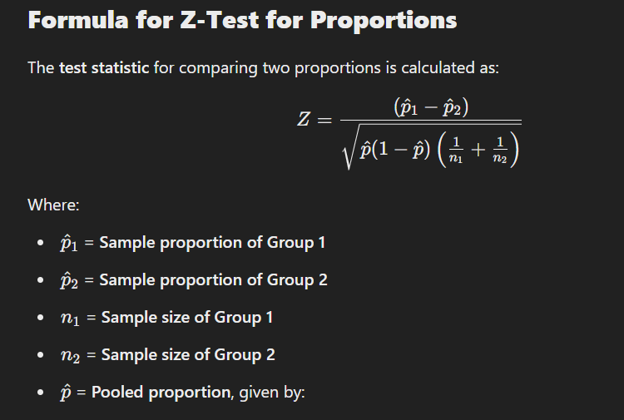

Industrial Example: A/B Testing in Digital Marketing
Scenario
A company runs an A/B test to determine if a new landing page design improves the conversion rate compared to the existing design.
✔ Group 1 (Old Design): 1000 visitors, 120 converted
✔ Group 2 (New Design): 1200 visitors, 180 converted
The company wants to test if the new design leads to a significantly higher conversion rate.

Step 1: Define Hypotheses
- Null Hypothesis H0​: The conversion rates of the two groups are equal.
H0: p1=p2​
- Alternative Hypothesis H1​: The conversion rates are different.
Ha: p1≠p2 ​
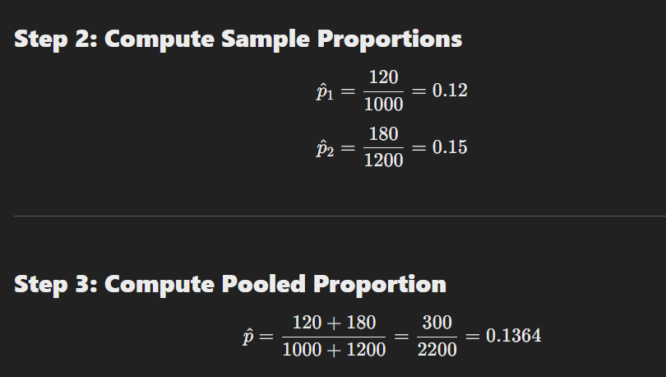
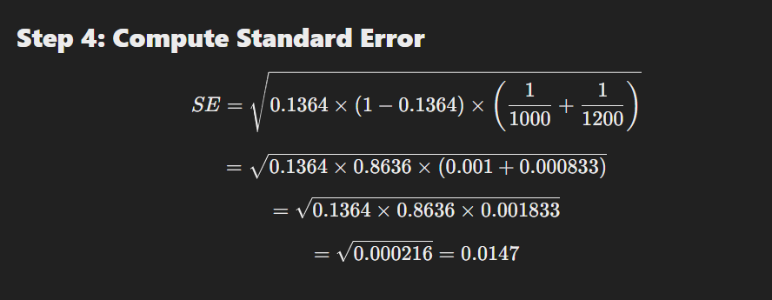
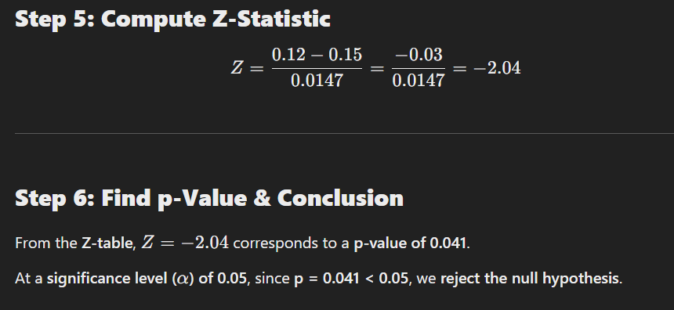
Step 7: Business Insights
📌 The new landing page design significantly improves conversion rates.
📌 The company should replace the old design with the new one.
📌 Further tests can analyse why the new design performs better (e.g., better UX, improved CTA).

Key Takeaways
✅ Z-Test for Proportions is useful for A/B testing, marketing analysis, customer surveys, and medical studies.
✅ Helps determine if a change (e.g., new product, policy, design) leads to a significant impact.
✅ Works best for large sample sizes with categorical data.

Kaplan-Meier Curve: Analyzing Survival Data (Customer Retention)
What is the Kaplan-Meier Curve?
The Kaplan-Meier (KM) curve is a non-parametric statistical method used to estimate the survival function over time. It helps analyse time-to-event data, such as:
✔ Customer retention (how long customers stay subscribed)
✔ Machine failure rates (when a machine breaks down)
✔ Patient survival rates (how long patients survive after treatment)
When to Use the Kaplan-Meier Curve?
✅ When analysing the time until an event happens (e.g., customer churn, machine failure).
✅ When not all subjects experience the event (some customers might still be active at the end of the study).
✅ When survival data is censored (some subjects are lost to follow-up before the event occurs).

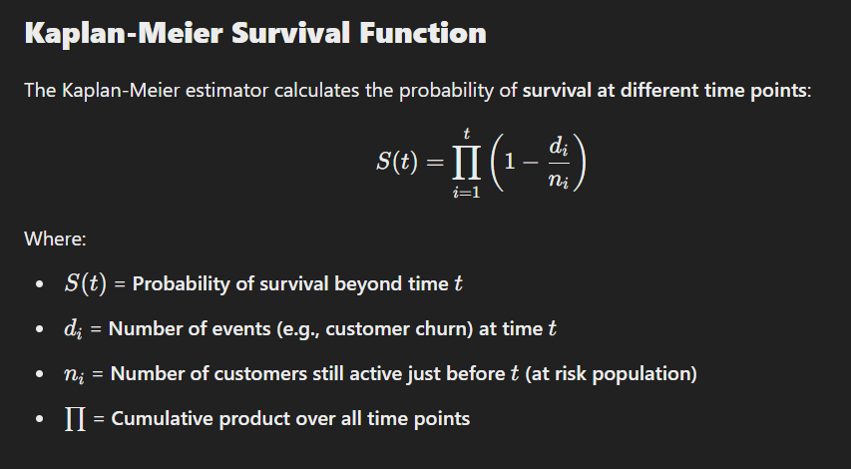
Industrial Example: Customer Retention in a Subscription Service
Scenario
A streaming service wants to analyse how long customers stay subscribed after signing up.
📌 Data Collected:
- Customers are monitored for 12 months.
- Some customers churn (cancel subscription), while others remain active at the end.
- Some customers are lost to follow-up (e.g., stopped responding but didn’t officially cancel).
Step 1: Collect Data
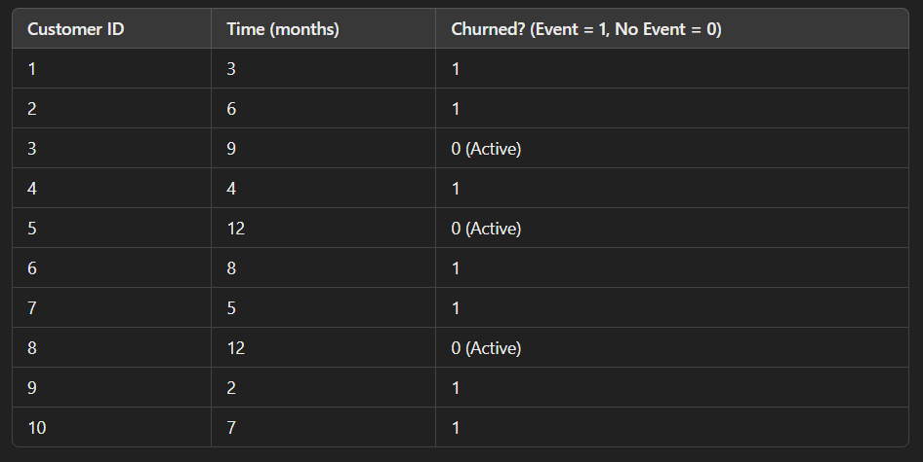
Step 2: Calculate Survival Probability
Using the Kaplan-Meier estimator, we compute the cumulative survival rate at each time event.
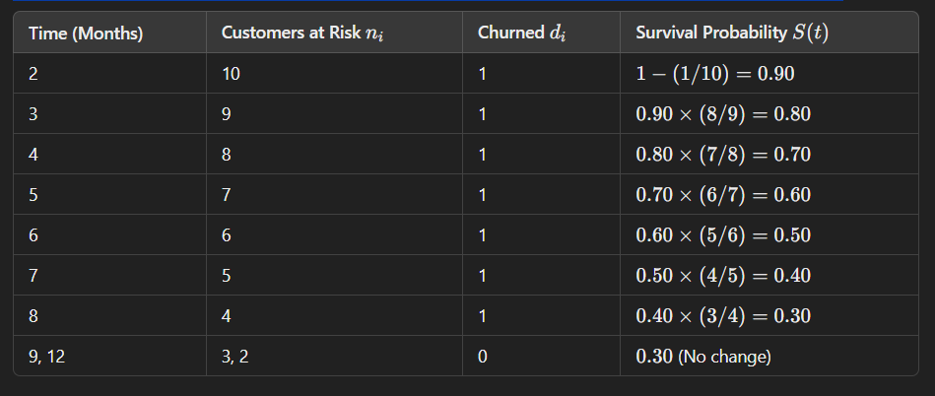
Step 3: Plot the Kaplan-Meier Curve
A Kaplan-Meier survival curve is plotted with:
- X-axis = Time (months)
- Y-axis = Survival probability S(t)
📉 The curve drops at each churn event, showing how retention declines over time.

Step 4: Business Insights
📌 50% of customers churn by the 6th month.
📌 Retention stabilizes after 9 months, suggesting a core loyal user base.
📌 The company should introduce retention strategies (discounts, new features) by Month 3–5 to prevent early churn.

Key Takeaways
✅ Kaplan-Meier Curve is a powerful tool for analysing customer retention, machine reliability, and patient survival.
✅ It accounts for censored data, making it more accurate for real-world survival analysis.
✅ Helps businesses predict when customers will churn and implement strategies to improve retention.

Cox Proportional-Hazards Model: Understanding Factors Affecting Survival Time
What is the Cox Proportional-Hazards Model?
The Cox Proportional-Hazards (Cox PH) model is a semi-parametric survival analysis method used to examine the relationship between multiple predictor variables (features) and the time until an event occurs (survival time).
Unlike the Kaplan-Meier curve, which only describes survival probabilities over time, the Cox PH model can analyse the impact of different factors (e.g., customer demographics, machine usage, patient characteristics) on survival.

When to Use the Cox Proportional-Hazards Model?
✅ When analysing time-to-event data (e.g., customer churn, machine failure, patient survival).
✅ When you want to quantify the impact of multiple factors on survival time.
✅ When the hazard ratio is assumed to be proportional over time (meaning the effect of a variable remains constant).

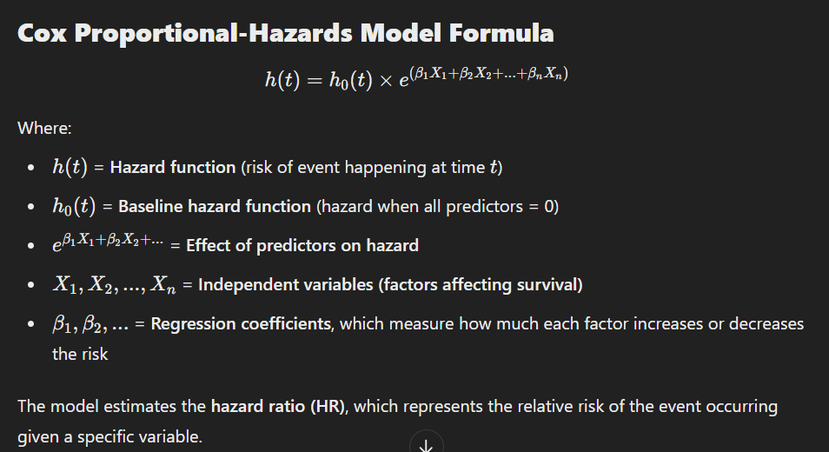
Industrial Example: Customer Churn Prediction for a SaaS Company
Scenario
A SaaS (Software as a Service) company wants to understand which factors influence customer churn and when customers are most likely to leave after signing up.
📌 Dataset Includes:
- Time (months) before the customer churned or was last observed.
- Churn (1 = churned, 0 = still active at the end of the study).
- Independent variables affecting churn:
  - Subscription Type (Basic, Premium)
  - Monthly Usage Hours
  - Customer Age
  - Support Ticket Frequency (number of times a customer contacted support)
Step 1: Data Collection
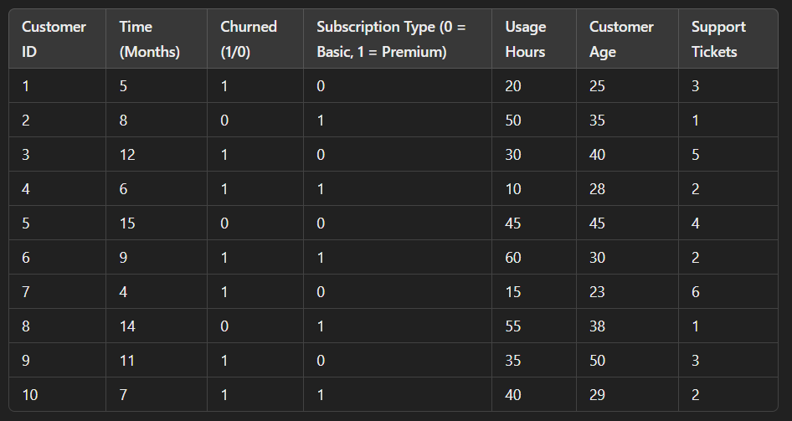
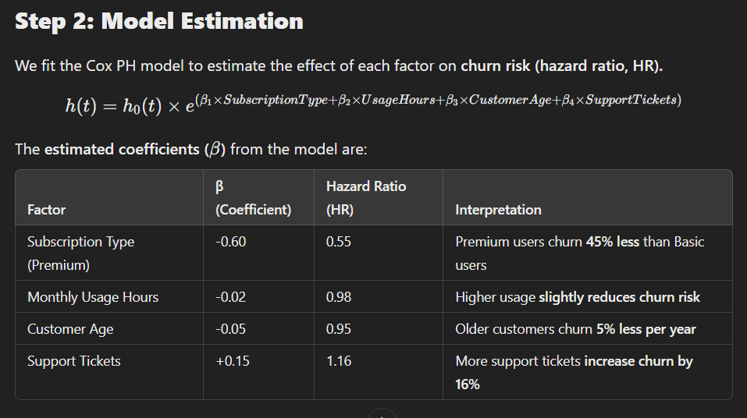
Step 3: Interpret Results
✔ Subscription Type (Premium) → Reduces churn risk by 45% compared to Basic users.
✔ Higher Usage Hours → Customers who use the service more are less likely to churn.
✔ Older Customers → More loyal compared to younger customers.
✔ Support Tickets → More issues lead to higher churn, suggesting customer dissatisfaction.

Step 4: Business Insights & Recommendations
📌 Offer incentives for Basic users (discounts, exclusive features) to encourage retention.
📌 Encourage higher usage through personalized recommendations, reminders, and engagement campaigns.
📌 Improve customer support to resolve issues faster and reduce churn.
📌 Focus retention efforts on younger users who tend to leave earlier.

Key Takeaways
✅ Cox Proportional-Hazards Model is useful for analysing time-to-event data with multiple predictors.
✅ It estimates the hazard ratio (HR), which shows how each factor affects survival (or churn, failure, etc.).
✅ Helps businesses identify key drivers of churn and develop targeted retention strategies.

